Question 11 pts
Which of the following research question can be answered with a repeated-measures ANOVA?
 | Does high school student's GPA differs according to the mother's highest level of education?
 | Does the current presidential approval rating differs significantly across different age groups?

 | Does response time on a perceptual task differ significantly after drinking different amount of coffee?
 | Does the number of withdrawals from a course differs across the different delivery formats (online, in-person, hybrid) for the same course?

Flag this Question
Question 21 pts
In a within-subjects study, subjects' memory performance were measured three times with 5-year intervals to see if there are significant changes over time. The ANOVA output includes the following table, which shows that ____.
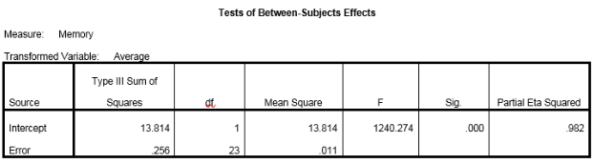
The individual differences in memory scores are significant.
The sphericity assumption of the data is violated.

The memory scores are significantly different between the three time points.
The grand mean of memory scores is significantly different from 0.
Question 31 pts
Which of the following is an appropriate rationale for adopting a within-subjects design for a study?
To target specific groups within the population of interest for recruitment.
To conserve research resources by recruiting a smaller number of subjects.

To reduce the impact of individual differences in the analysis.
To give the subjects opportunity to practice the experimental task by having each subject go through multiple sessions.

Flag this Question
Question 41 pts
Tests of within-subjects contrasts are performed following _____.
a significant one-way factorial ANOVA
a significant interaction effect in a two-way factorial ANOVA

a significant main effect in a two-way factorial ANOVA
a significant one-way repeated-measures ANOVA

Flag this Question
Question 51 pts
Given the formula F = MS_{effect} / MS_{error}, a within-subjects design affects the ANOVA result primarily by _____, compared to a between-subjects design for the same study.
reducing MS_{error}
reducing both MS_{effect} and MS_{error}

increasing both MS_{effect} and MS_{error}
reducing MS_{effect}
Question 61 pts
A one-way repeated-measures ANOVA is most similar to _____.
paired-samples t test
independent-samples t test

z test
one-sample t test

Flag this Question
Question 71 pts
A researcher hypothesizes that a patient's length of survival (recorded in number of weeks between diagnosis and death) after the brain tumor diagnosis might be related to the location of the primary tumor (with 5 locations: frontal lobe, temporal lobe, parietal lobe, occipital lobe, or sub-cortical regions). Furthermore, she also suspect that such a location effect may vary by gender (male vs female). What is the best way to analyze the data?
A one-way ANOVA with tumor location as IV and post hoc tests to examine the two gender groups
A two-way ANOVA with tumor location and gender as IVs

A one-way ANOVA with tumor location as IV and an independent-samples t test with gender as IV
A one-way ANOVA with tumor location as IV and a one-way ANOVA with gender as IV

Flag this Question
Question 81 pts
Below is the result from a 2x2 factorial ANOVA on teacher salary, with the factors of gender (male vs female) and community type (suburban vs rural). What are the degrees of freedom for reporting the gender x community interaction effect?
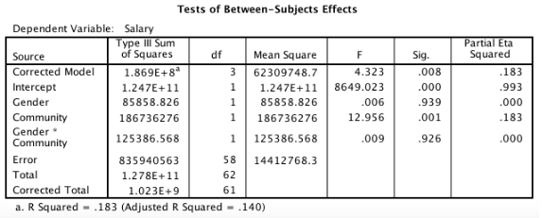
https://gyazo.com/77a3c1017efbec09987b64549f411bbf (Links to an external site.)Links to an external site.
3, 62
1, 62

1, 58
3, 58
Question 91 pts
An instructor examines her students' final grades from three different sections (online, face-to-face, hybrid) of an introductory statistics course to see if coures delivery modality has an impact on the final grade. She is also interested in whether male students and female students show different patterns of grade differences between course modalities. A two-way ANOVA will be conducted to compare ____ groups of scores.
2
6

3
5

Flag this Question
Question 101 pts
A three-way ANOVA has ____.
three independent variables
three groups to compare

three effects to examine
three dependent variables

Flag this Question
Question 111 pts
To report the omnibus test result from the following table, which format of the p value meets the APA standards? Assume that the alpha level is .05.
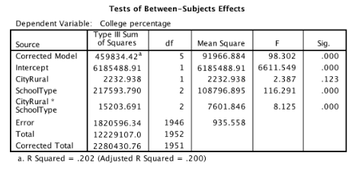
p < .001
p = 0

p < .05
p = .000

Flag this Question
Question 121 pts
The sale amount was analyzed by store location and shelf position. Based on the output table below, how many cells (groups) were in the factorial design?
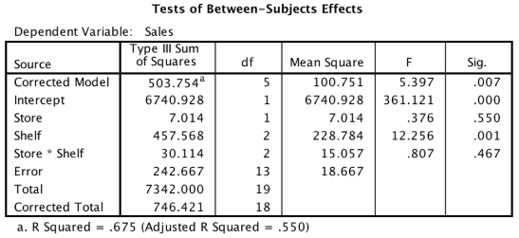
4
5

2
6
Question 131 pts
Based on the ANOVA results below, what post hoc tests should be performed?
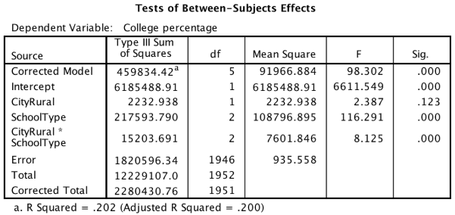
Post hoc tests for the CityRural effect
Post hoc tests for the SchoolType effect

post hoc tests for the CityRural x SchoolType effect
Post hoc tests are not necessary

Flag this Question
Question 141 pts
Which of the following is a correct report from this ANOVA table?
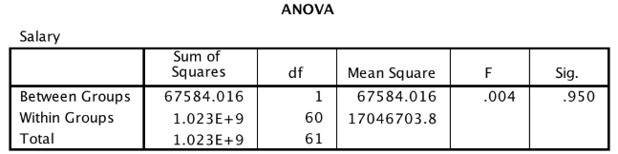
p = .004
p = .950

F(1,61) = .004
F(1, 60) = .950

Flag this Question
Question 151 pts
What is the effect size (η²) of the following one-way ANOVA?
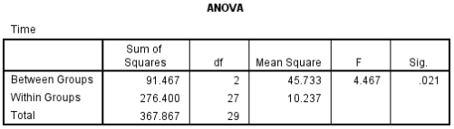
4.467
.021

.249
.751

Flag this Question
Question 161 pts
Which of the following research questions could not be answered with a one-way ANOVA?
The instructor examines her students' final grades in her introductory statistics course by comparing the freshmen, the sophomores, the juniors, and the seniors in the class.
Data were collected on satisfaction with life from a group of dog owners and a group of cat owners. An additional group of subjects without any pet also provided data on their satisfaction with life, which is measured with a rating scale instrument and can be treated as a continuous variable.

An experiment was conducted to compare test scores after studying while listening to one's favorite music with test scores after studying in completely silence. The same subjects study with their favorite music before the mid-term exam and then study without music before the final exam. Mid-term exam scores and final exam scores are compared.
A group of male students and a group of female students from a local high school participated in a study to examine their social networking behavior. Specifically, the number of selfies taken and sent to friends via social networking apps was recorded for each student. The researcher hypothesized that there is a gender difference in terms of the average number of selfies sent each day.
Question 171 pts
Judging from the output table of a one-way ANOVA, how many groups were compared?
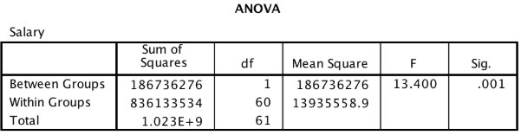
2
1

62
60

Flag this Question
Question 181 pts
Which of the following is one of the assumptions for analysis of variance?
The IV must have three or more levels.
The groups being compared must be the same size.

The IV must be normally distributed.
The DV must be an interval or ratio variable.

Flag this Question
Question 191 pts
One-way ANOVA differs from independent-samples t test in that ____.
the DV must be a continuous variable in one-way ANOVA but not in independent-samples t test
the assumption of equal variances needs to be met for one-way ANOVA but not independent-samples t test

the significance of the hypothesis test is determined by the p value in one-way ANOVA but by the t value in independent-samples t test
one-way ANOVA can be used to compare any number of groups while independent-samples t test can only be used to compare two groups

Flag this Question
Question 201 pts
The instructor for an introductory statistics course would like to know if a student's final grade in the course would vary depending on what math course (AP statistics, calculus, or non-calculus math) was taken by the student in her/his high school senior year. Which of the following is an adequate hypothesis test for this research project?
One-way MANOVA
One-way ANOVA

Three-way ANOVA
Two-way ANOVA

